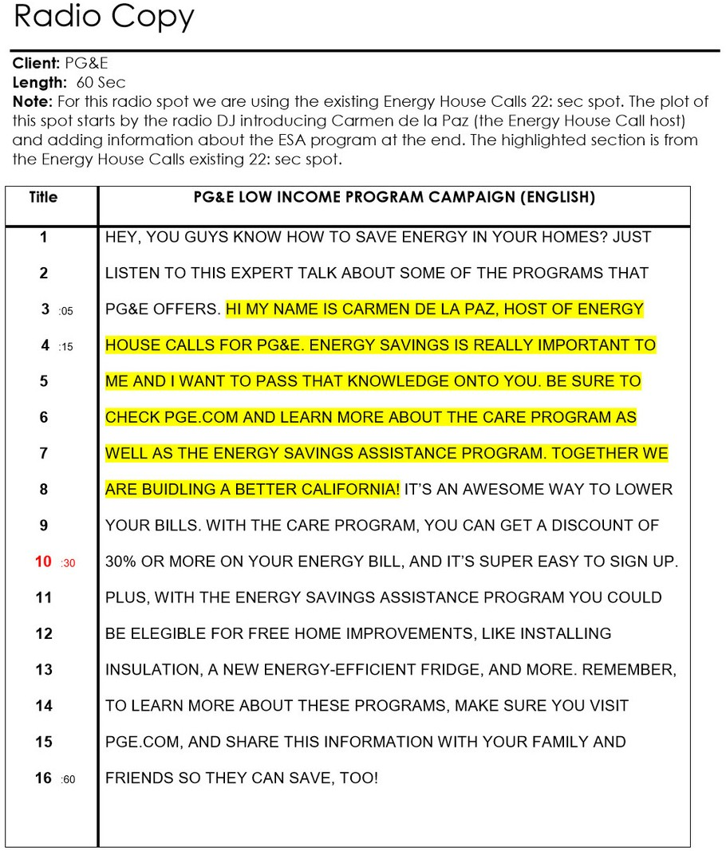

Compliance Packaging Campaign

(Music)

No more sorting meds, waiting in line, or chasing down reﬁlls. *_______ Pharmacy oﬀers PakMyMeds compliance packaging.* Here’s how it works...

We work directly with your doctors and insurance to save you the time and frustration.

We monitor and sort all of your prescriptions by date and time — organize them into compliance packages so you can pick them up with no wait.

No more requests for reﬁlls and no more sorting.

*We do it all for you at Sherrie’s Pharmacy. Call us at 404-­‐777-­‐2112 Compliance packaging at _______Pharmacy. Simply your life.*

COMC CLIENT: COMPLIANCE PACKAGING RADIO

LENGTH: 0:30



Phone: 877.797.2332

Email: [info@rxsafe.com](mailto:info@rxsafe.com) [www.rxsafe.com](http://www.rxsafe.com/)

2453 Cades Way, Suite A Vista, CA 92081